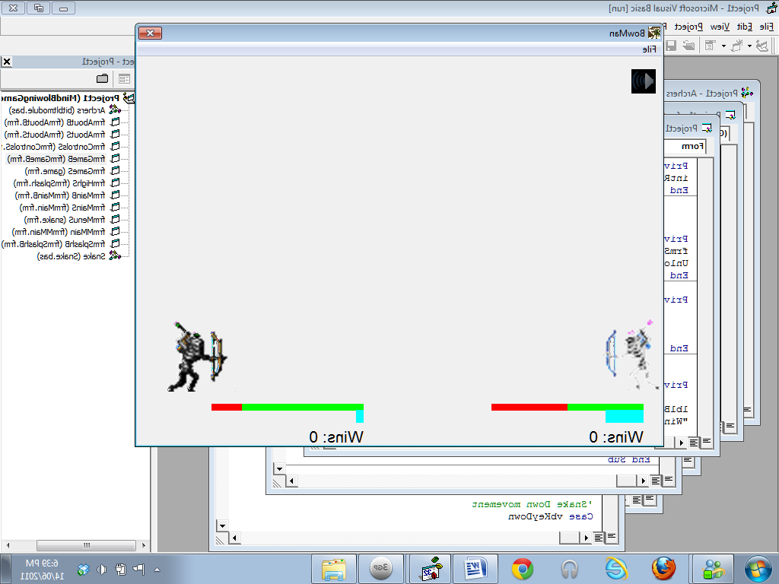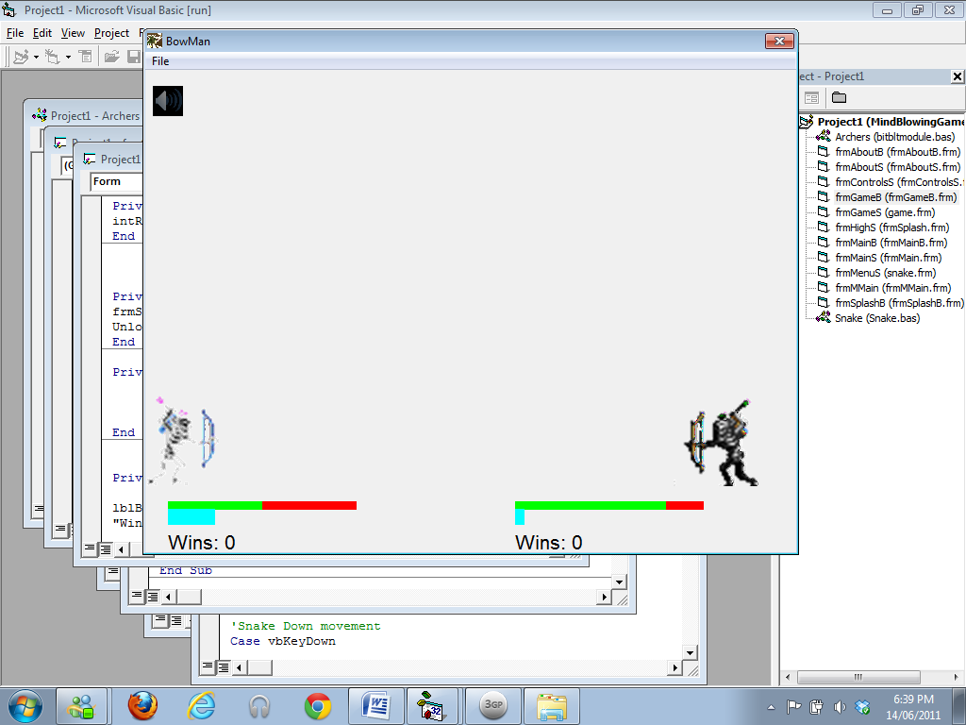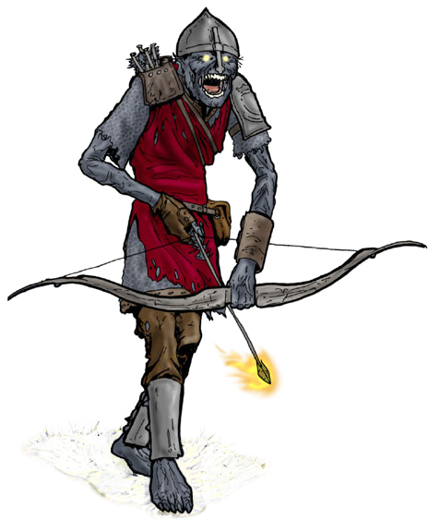

**About this game:** This is a two player game in which each player controls a skeletal archer. The objective of the game is to beat the other player by shooting arrows at them until their health bar disappears. The game includes a momentum bar which, if completely filled, will allow the archer to summon a frenzy of arrows which is a one hit kill move if not dodged or countered.

Features and Instructions: The Objective of the game is to kill the other player by shooting arrows at them. The features for each form are:

* Main Menu
* Drag and Drop the character into the player 1 or 2 box.
* If you wish to reselect your character, click the reset button
* (Optional) Click on the “About” button to open an about screen that contains a basic description of the game.
* (Optional) Click on the “Controls” button to open an about screen that contains the basic rules and controls of the game.
* After choosing your characters, click the Start button to redirect to the game.

